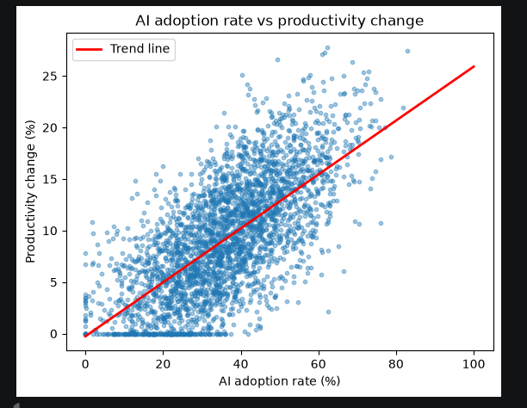
Why a scatter plot is the appropriate chart — A scatter plot is the correct chart for examining the relationship between two continuous variables, because each point represents one company-quarter's paired values. Only a scatter plot can show this — a histogram or boxplot looks at one variable at a time and can't reveal how two variables move together. This is THE chart for your core research question: does AI adoption rate relate to productivity change?
What this specific plot shows — The point cloud rises from bottom-left to top-right, and the fitted trend line makes the direction and rough strength of that relationship visible at a glance. Clear positive relationship: as AI adoption rate increases, productivity change tends to increase too. The upward-sloping trend line confirms this isn't random scatter — there's a consistent pattern across the full range of adoption rates. The spread (points scattered above/below the line) shows the relationship is real but not perfectly deterministic — other factors also affect productivity.
Something to flag: the flat line at y=0 — Zoom in on the bottom edge of your chart — there's a horizontal band of points sitting exactly at productivity_change_percent = 0, cutting across a wide range of adoption rates. This looks like a distinct subgroup (possibly a data-collection quirk, a specific survey source, or genuinely stagnant companies) rather than random noise — worth investigating further before Phase 2 modelling.
What the rubric wants beyond the plot — Task 4 asks you to analyse relationships between variables and summarise insights, not just display the chart. Describe the relationship: direction (positive), strength (moderate-to-strong visually), and linearity (roughly linear, not curved). Comment on the spread/scatter around the trend line — what does the variability suggest about other unmeasured factors? Tie it back to the research question: does this support or challenge the idea that AI adoption drives productivity gains?

